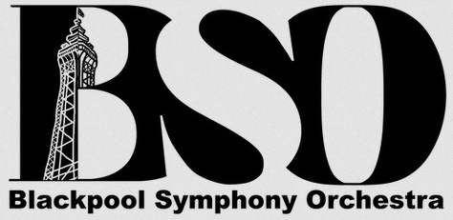
Blackpool Symphony Orchestra
Blackpool Symphony Orchestra is an amateur orchestra that brings together able local players and exceptional soloists to perform major orchestral masterpieces and other works of musical interest. We present an annual series of 3 or 4 concerts and organise educational and community outreach projects.
Although its members are mainly adults, some young people (under the age of 18 years) are involved in the activities of the Orchestra, usually as players. We welcome and actively encourage the involvement of such young people, to foster their musical development and as a way of encouraging future membership. However, we need to ensure their safety and well-being while in our care.
Please complete the form below and return to Wendy Pallant (violin), Sue Sargent (flute) or Alexander Roe (Viola).
PERMISSION FORM
I give permission for my child (full name) _________________________________________
to take part in the activities organized by Blackpool Symphony Orchestra. I have received, read and understand the contents of the Safeguarding Policy.
I agree that I will be responsible for transporting/ensuring the safe transport of my child to and from rehearsals and concert venues.
I do/do not* give permission for my child to be included in small group/full Orchestra photos which may be used in orchestral literature or on the website.
Signed:
Parent/Guardian Name:
Date:
Emergency Contact Details
Contact 1
Name: Relationship:
Phone Number: Mobile Number:

Contact 2
Name: Relationship:
Phone Number: Mobile Number:

Emergency Details
Child’s Full Name: Date of Birth:
Address:

